EXERCISE-20

20.Design TM using simulator to perform subtraction of aaa-aa

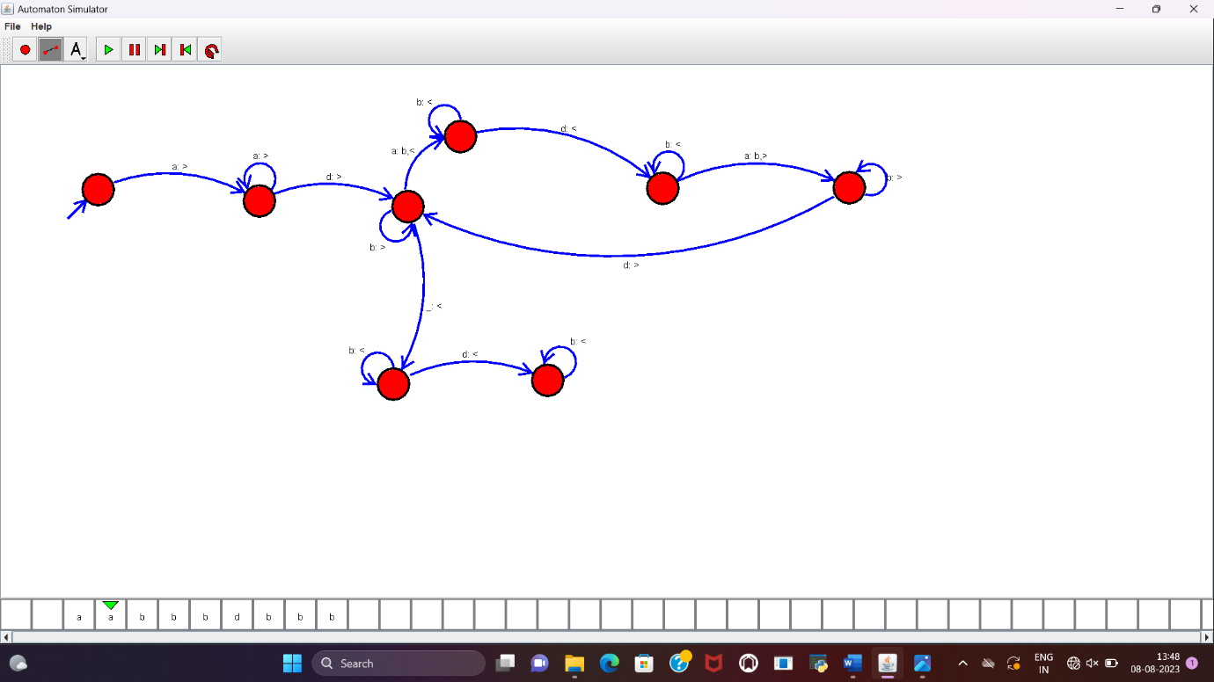

RESULT:

TM to perform the subtraction of “aaa”-“aa” is designed and implemented successfully.